Central Michigan University Department of Statistics, Actuarial and Data Sciences

Handbook for Internships

This handbook consists of two parts: PART I: Teaching Internship for PhD students.
Course #: STA 794
PART II: Non-Teaching Internship for PhD and MS students.
Course #: STA 795, STA 695

CHAPTER 1: TEACHING INTERNSHIP ..................................................................................................... 3

  - WHAT IS A TEACHING INTERNSHIP? 3
  - PREREQUISITE 3
  - GUIDELINES FOR STUDENT INTERN 3
  - RECOMMENDED PRACTICES FOR FACULTY MEMBER 3
  - PROCEDURE TO BE FOLLOWED BY STUDENT INTERN AND FACULTY MEMBER 3
  - EVALUATION CRITERIA 4
CHAPTER 2: NON-TEACHING PROFESSIONAL INTERNSHIP .................................................................... 5
  - WHAT IS A NON-TEACHING PROFESSIONAL INTERNSHIP EXPERIENCE? 5
  - PREREQUISITE 5
  - LEARNING OBJECTIVES 5
  - EVALUATION CRITERIA 5
  - RESPONSIBILITIES OF THE STUDENT 6
  - THE TIME FRAME FOR THE INTERNSHIP 7
  - RESPONSIBILITY OF FACULTY INTERNSHIP COORDINATOR 7
  - RESPONSIBILITY OF INTERNSHIP AGENCY 8
  - WHERE DO YOU LOOK FOR INTERNSHIPS? 8
  - HOW TO GET AN INTERNSHIP? 8
  - WHAT IF A STUDENT IS ALREADY WORKING AT AN AGENCY/COMPANY? 9
  - SPECIFIC INSTRUCTION FOR INTERNATIONAL STUDENTS HOLDING F1 VISA 9
  - IF A STUDENT PLANS TO PURSUE AN INTERNSHIP OUT OF THE STATE OF MICHIGAN 10

APPENDIX A: INSTRUCTION FOR CREATING AN E-JOURNAL ON THE BLACKBOARD COURSE SHELL FOR BOTH TEACHING AND
NON-TEACHING INTERNSHIPS 11
APPENDIX B: GUIDELINES FOR DOCUMENTING PORTFOLIO FOR TEACHING INTERNSHIP 16
APPENDIX C: TEACHING INTERNSHIP FACULTY MEMBER COMMENT FORM (AN EXAMPLE) 17
APPENDIX D: GUIDELINES FOR DOCUMENTING FINAL INTERNSHIP REPORT FOR NON-TEACHING INTERNSHIP 18
Appendix E: Teaching Internship Assessment Form Evaluation of Intern and Internship Portfolio by the Internship Faculty Member 19
Appendix F: Non-Teaching Internship Application Form (To be completed by the student) 20
Appendix G: Non-Teaching Internship Credit Agreement Form (To be Completed by the Field Supervisor)
........................................................................................................................................................................21
APPENDIX H: EVALUATION FOR M OF INTERN BY THE FIELD SUPERVISOR FOR NON-TEACHING INTERNSHIP 22
APPENDIX I: EVALUATION FORM OF INTERN BY THE FACULTY INTERNSHIP COORDINATOR FOR NON-TEACHING INTERNSHIP…23 APPENDIX J: INTERNSHIP AGREEMENT BETWEEN CENTRAL MICHIGAN UNIVERSITY BOARD OF TRUSTEES 24
APPENDIX K: CHECKLIST FOR COMPLETING A NON-TEACHING INTERNSHIP 25

NOTE: THE FORMS ARE ALSO AVAILABLE ON THE STATISTICS, ACTUARIAL AND DATA SCIENCES DEPARTMENT WEB SITE AT HTTPS://WWW.CMICH.EDU/COLLEGES/CST/MATH/PAGES/INFORMATION-FOR-CURRENT-GRADUATE-STUDENTS.ASPX

This handbook was created in accordance with the “2015 Domestic Agreements: Handbook of Procedures & Guidelines; for Internships, Clinical Placements and Field Experiences” prepared by the Office of Academic Effectiveness at https://www.cmich.edu/office_provost/AcademicAffairs/Agreements/Documents/Handbook%20of%20P
rocedures%20-%209.2015.pdf Created & Approved in December, 2018

Chapter 1: Teaching Internship
Internship is a required component for PhD students in the Department of Statistics, Actuarial and Data Sciences. There are two types of internships. One is Teaching Internship (STA 794), the other is Non-Teaching Internship (STA 795). Students are required to choose either STA 794 or STA 795. This Chapter describes the guidelines of taking STA 794, Teaching Internship course.

What is a teaching internship?
The teaching internship is designed to give practical experience in the teaching of undergraduate courses in the Department of Statistics, Actuarial and Data Science, which can be either face-to-face on-campus or online courses, excluding 500 level courses.

Prerequisite
Successful completion of all required qualifying exams.

Guidelines for Student Intern
    - The class size of the course for the teaching internship should be the same as the class size of three credit hours of the same course assigned to regular faculty.
    - The class format may be a face-to-fact or an on online format.

Recommended Practices for Faculty Member
    - Only tenured/tenure-track faculty in the Department of Statistics, Actuarial and Data Sciences can be an internship faculty member.
    - It is recommended that the faculty member have taught the course at CMU before working with a graduate student intern. If this is not the case, the faculty member should address their experience in the internship application.
    - In order to balance the teaching assignments among regular faculty, it is recommended that each regular faculty member serve as a teaching internship faculty member for only one course, which is either three (3), per academic year.
    - The courses must be selected from courses offered during the Fall and Spring semesters.

Procedure to be followed by Student Intern and Faculty Member
An e-mail will be sent to inform all PhD students to complete and submit an online application form in early March (for fall semester internship) and in September/October (for spring semester internship). After completing the prerequisites, students are required to take the following procedure to make the request.
- The student finds the course s/he plans to teach as an internship course, consults with his/her academic advisor about the choice and receives his/her agreement.

- The student talks to the course instructor to receive his/her agreement to participate in the teaching internship. The student must be aware of the guidelines described above when looking for the internship faculty member.
- The student completes the online application form, which must also be approved by the faculty member, and then submits the form to the Graduate Coordinator.
- The Graduate Committee reviews and approves the request, which is then given to the Department Chair for final approval. The final list should be given to the Office Professional for inclusion on the schedule.
- During the internship semester, the student intern is required to regularly document teaching related practices. This should provide regular opportunity for documented reflection. These documents are part of the portfolio to be submitted to the faculty member and Department. The items of the portfolio are detailed in Appendix B.
- During the internship semester, regular written feedback is to be given to the Student Intern by the Faculty Member for most of the class meetings. A sample comment form example is given in Appendix C. This assessment must be shared with the intern prior to the next class meeting. The intern is required to submit these assessments in the portfolio.
- During the final exam week, the intern is required to submit the portfolio to the internship faculty member. An electronic copy of the portfolio will be submitted by the Student Intern to Office Professional of the Department who will archive the portfolio each semester on the Graduate Committee Portal. Regular faculty members of the Department can review the portfolio.
- The Internship Faculty member will submit the completed Teaching Internship Assessment Form, found in Appendix E to the Graduate Coordinator for use in our program assessment report.

Evaluation Criteria
The internship is viewed as a capstone experience for teaching an undergraduate level statistics or related courses. The final grade is Credit/No Credit, and it is determined by the faculty member based on the following documents:
    - The observation assessment documents: The intern will collect the observation assessments made by the faculty member during the semester, and scan these documents as part of the portfolio package.
    - Portfolio: Upon completion of each internship experience, the student will submit a portfolio to the faculty member and a copy to department office during the final exam week.

The final grade will be determined by the internship faculty member based on the semester observation by the faculty member and the portfolio submitted by the student intern.

Chapter 2: Non-teaching Professional Internship

This chapter describes the guidelines of non-teaching internship for PhD students choosing to take STA 795 and for students in M.S. in Applied Statistics and Analytics who sign up for STA 695. Appendix K is the Check List of the process for completing the non-teaching internship.

What is a non-teaching professional internship experience?
The goal of the non-teaching internship program in the Department of Statistics, Actuarial and Data Sciences is to provide a learning experience to the student and to foster a successful partnership that is mutually beneficial to the student and the sponsoring organization. Internships are designed to be hands-on, well-structured, professional work experiences with an organization related to the student’s academic program or career field of interest.

Prerequisite
For PhD students: Successful completion of all required qualifying exams. Permission of the faculty internship coordinator.
For MS students: Successful completion of the first year of academic work. Permission of the faculty internship coordinator.

Learning Objectives
After successful completion of this course, the student will be able to
    - lead and manage a real world project,
    - apply advanced statistical and/or mathematical knowledge to work on real world projects,
    - use computing technology and skills to analyze data,
    - communicate and work with team members to solve real world problems, and
    - write reports and make oral presentations on solutions to problems.

Evaluation Criteria
- Internship Portfolio and Report
The intern will be required to provide an internship portfolio, including at minimum the following items:
- A description of the internship position and experience, documentation of the acquisition of specific skills or knowledge and evidence of achievements,
- All weekly journal entries from Blackboard (See Appendix A: Instruction for creating e-
Journal on Blackboard Course Shell), and
- A final internship report that that consists of a summary of major projects and accomplishments, and lessons learned from the internship experience (See Appendix D: Guidelines for Documenting Final Internship Report for Non-Teaching Internship).

Field Supervisor Evaluation
An evaluation form will be completed by the Field (Job) Supervisor.
(See Appendix H: Field Supervisor Evaluation Form for Non-Teaching Internship)
- Grade Evaluation will be Credit/No credit. The faculty internship coordinator will be the faculty who determines the final grade based on the evaluation documents: internship portfolio and report, and Field Supervisor Evaluation.

Responsibilities of the Student
- Prior to seeking internship opportunity, the student is required to
  - Prepare a resume.
  - Consult with the faculty internship coordinator about the procedure and policy of internship and identify potential internship opportunities that fit the student’s interests and career choices.
  - Browse the websites of the agencies to learn about their history, products, services, etc.
  - Register for the internship course (STA 795 for PhD students or STA 695 for MS students).

Process of seeking an internship:
  - It is the student’s responsibility to seek an internship. Some potential internship opportunities may be available at the department office. Some professional organizations, e.g., the American Statistical Association, often post internship opportunities on the organization’s website.
  - Once internship opportunities are identified, the student is required to consult with the faculty internship coordinator to approve the adequacy of these internship opportunities.
  - The student should then contacts the internship agencies approved by the faculty internship coordinator to secure an informal agreement (e.g., an e-mail message) from the internship agency.
  - After securing the internship,
    - Contact the field supervisor at the company/agency to determine the internship time period, and the number of hours per week.
    - The student is required to complete two forms:
- Department Internship Form for Non-Teaching Internship (Appendix F ) and
      - Credit Agreement Form for Non-Teaching Internship (Appendix G).
  - After completion of the forms, the student should
    - make an appointment with the faculty internship coordinator to submit the Department Internship Form, which requires the signature of the faculty internship coordinator; and
    - If the internship is not a paid internship, the student needs to make an appointment with Mitchel Hartman (phone: (989)774-7211, e-mail: hartm1m@cmich.edu ), the Coordinator, Affiliation Agreement in the Office of Academic Affairs to have the
University Agreement Form signed. The University Agreement Form for Non-Teaching Internship (Appendix J) requires the signatures of both the internship agency and the Academic Affairs Vice Provost.

Prior to working in the internship agency:
  - Make an effort to learn more about the internship agency, e.g., check the agency’s website to get more familiar with the agency’s history, products, services, etc.

While working as an intern in the internship agency:
  - When the internship begins, go to work with a positive proactive working attitude.
  - Learn and follow the company/agency’s employee guidelines.
  - Keep track of your duties and progress.
  - Document your work on the Blackboard site on a weekly basis. (See Appendix A: Instructions for creating weekly e-Journal entries on the Blackboard).
  - By the end of the internship, prepare a final report that summarizes the major projects, outcomes, and lesson learned.

After completion of the internship:
  - Write a letter of appreciation to the Field Supervisor and the Agency.
  - Complete and submit your internship portfolio and report.
  - Make an appointment with the faculty internship coordinator to share your internship experience.

The time frame for the internship
Once the internship agency has been determined, the student is required to meet with the field supervisor to discuss the working time frame of the starting and ending dates.
- For a full-time student, it is strongly recommended that the student look for an internship during the summer term for three months (Early May to Early August).
- For a part-time student, s/he may choose to take the internship during the fall or spring semester with the approval of the faculty internship coordinator and the internship agency.
- The number of hours of work per week is 40 hours.
- The total number of hours for the internship cannot be less than 400 hours (or 10 weeks of full-time work).

Responsibility of Faculty Internship Coordinator
- Seek potential internship opportunities for students.
- Communicate with students their responsibilities regarding internships as described in section 2.5.
- Communicate with the field supervisor of the Internship Agency regarding the student intern’s progress.
- Keep track of internship progress of each student during the internship period.
- Communicate with each intern after completion of the internship regarding portfolio and final report submission.

- Evaluate student intern’s learning outcomes and assign a grade using the Non-Teaching Internship Faculty Coordinator Evaluation Form (Appendix I).

Responsibility of Internship Agency
- Designate a supervisor who will be available to mentor the intern.
- Provide any pre-placement information that needs to be shared with the intern, and provide any necessary work orientation to the intern within the first week of placement.
- The Agency has the authority to request the withdrawal of any intern from the internship experience for reasonable cause related to the need to maintain an acceptable level of service and/or business operations. Such a request must be in writing. CMU will comply with such a request.

Where Do You Look For Internships?

Go to the Data Analytics Jobs and Internships web site created by Dr. Lee at http://people.cst.cmich.edu/lee1c/analytics_jobs/ for postings and career related information.
- Organizations may contact the Department of Statistics, Actuarial and Data Sciences seeking interns. These notices are posted on the bulletin boards outside the faculty internship coordinator’s office as they are received. You should check the bulletin board regularly for new internship opportunities. The notices are also sent out by the Department regularly.
- Students may make their own attempts such as
  - Use online Google search using the key words such as
Internships in data analytics in Michigan, Internships in statistics in Michigan,
Internships in data science and so on.
  - Sign up to the CMU’s Handshake web site sponsored by the CMU’s Career Services at https://www.cmich.edu/ess/careers/Pages/handshake.aspx . This is the point of contact between CMU and companies who are looking for employees. Regularly check the availability of jobs/internships posting on this site.
  - Letting friends and family know you are seeking an internship.
  - Making lists of possible internships by contacting companies or browsing company websites.
  - Networking with professional associations, especially the American Statistical Association (ASA) at http://www.amstat.org or other student organizations. ASA publishes a list of internship opportunities on the ASA web site regularly.
- Useful criteria for choosing your internship:
- Look for internships that provide meaningful working experience and fit your interests and area of study.
- Look for an Agency that provides sponsorship by an experienced, qualified, professional mentor.

How to Get an Internship?
Being hired for an internship requires the same attitudes and skills as finding a job after graduation. One good source of information about career planning is ‘ What Color is Your Parachute’. It is published annually and most every bookstore features it prominently. Another good source is CMU’s Career Services located at Ronan Hall, website at http://careers.cmich.edu.

What if a student is already working at an agency/company?
A student may be a part-time or full time employee of an agency/company when signing up for his/her internship. The student is allowed to use the work s/he is doing as an internship under the condition that the student and the agency/company agrees and signs the Internship contract with CMU, and the work supervisor agrees to be his/her internship supervisor. The time period to do the internship must be identified. During the internship time period, the student intern’s responsibilities are the same as those in other internships.

Specific instruction for international students holding F1 Visa
If you are an international student holding an F1 Visa, you need to apply for the Curricular Practical Training (CPT) in order to take the internship. A student must have been in F-1 status for at least one academic year in order to be allowed to participate in CPT. Below is the procedure for applying for the CPT:
- Secure an internship agency and complete the three forms (Statistics, Actuarial and Data Sciences Department Internship Form, Credit Agreement Form, and University and Agency Agreement Form).
- Register for the internship course. STA 795 for Ph.D. and STA 695 for M.S.
- Make an appointment with an OIA (Office of International Affairs) advisor and bring the following documents:
  - Passport and Form I-94;
  - Completed Curricular Practical Training Recommendation Form;
  - Letter of CPT offer from prospective employer stating terms, length and location of employment; or equivalently, the completed Credit Agreement Form;
  - Current and any previous I-20
- If it is determined that you are eligible to receive CPT, an OIA advisor will authorize the request. The advisor will update the records in SEVIS for CPT that is directly related to your major area of study.
- The OIA advisor will issue a SEVIS Form I-20 indicating that CPT has been approved. This updated Form I-20 will serve as a proof of your authorization to work.

IMPORTANT:
Students who have received one year or more of full-time CPT in an academic level are ineligible for Optional Practical Training (OPT) in that same academic level.

If a student plans to pursue an internship out of the State of Michigan
If a student is interested in internship in the state other than Michigan, the student will have to check if s/he is allowed to pursue internship in the state of his/her choice by going to the following website: https://global.cmich.edu/compliance/InternalResources.aspx. Then,
- Enter the state of the proposed internship.
- Select the category: Experiential Activities. If it shows as “Allowed” or “SARA member”, the student can pursue the internship in the state.
- If the state does not allow internships or no information, the student needs to contact Mitchel Hartman at 989-774-7211 (e-mail: hartm1m@cmich.edu) in the Office of Academic Effectiveness.

The term ‘SARA member’ stands for ‘State Authorization Reciprocity Agreement’, which is an agreement among member states, districts and territories that establishes comparable national standards for interstate offerings of postsecondary distance education courses and programs. SARA is overseen by a National Council and administered by four regional education compacts. Michigan is administered by MHEC, the Midwestern Higher Education Compact.
In states which Requires Authorization for CMU to offer “experiential activities”, the process could take in excess of 9 months from initial application to the other state’s accrediting body. Check with the Office of Academic Effectiveness prior to accepting any out-of-state placements for student internships, clinical experiences or field placements. States should be checked each time because requirements change regularly.

Appendix A: Instruction for creating an e-Journal on the Blackboard course shell for both Teaching and Non-Teaching Internships

You are required to create weekly e-Journal entries on the course (STA 795 and STA 695) Blackboard site for your Internship courses. The collection of these weekly e-Journal entries are part of the portfolio each intern must complete and submit to the internship faculty member for the teaching internship course, or to faculty internship coordinator for the non-teaching internship course.

Steps to create the internship weekly e-Journal entries using Blackboard tool ‘Journal’.

Create your Internship Portfolio Link on the Blackboard site, if it is not created: Place your cursor on the “+” sign and click on “Tool Link”

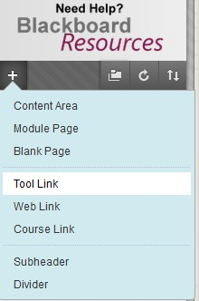
- Enter ‘Internship Portfolio’ as Name, choose ‘Journals’ as Type. Check ‘Available to Users, and click “Submit”.

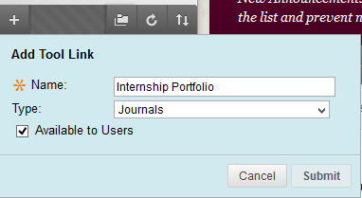

- The ‘Internship Portfolio’ Link appears on the left panel:

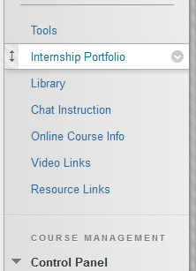
- Click on the Internship Portfolio link:



- Click on “Create Journal” to create a weekly e-Journal Entry.

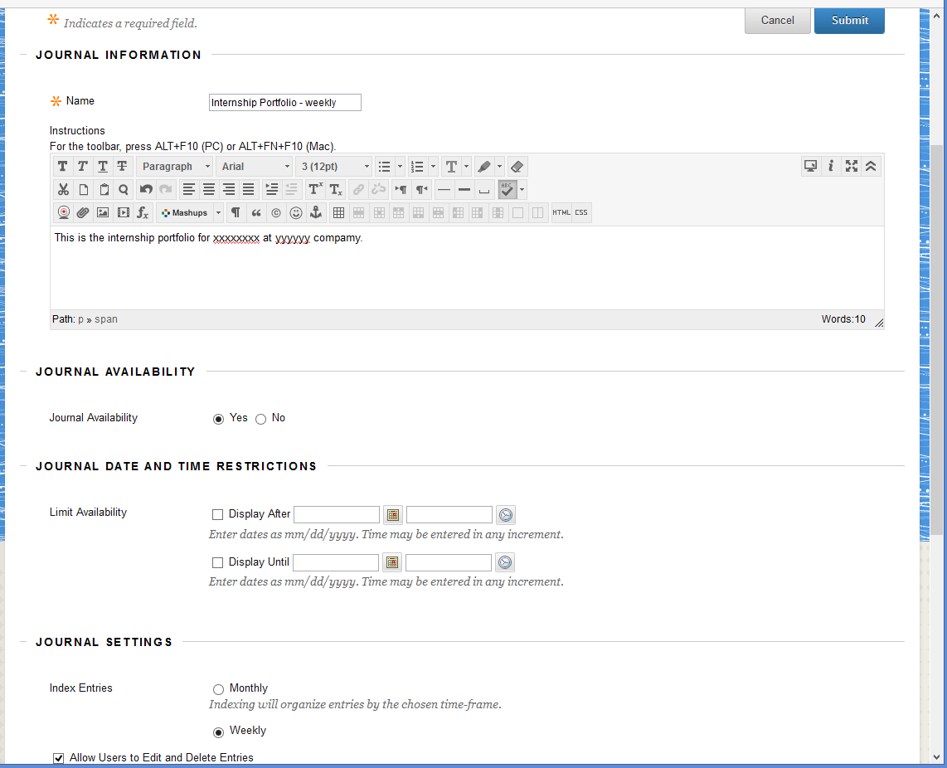

- After submitting the above table, you will see:

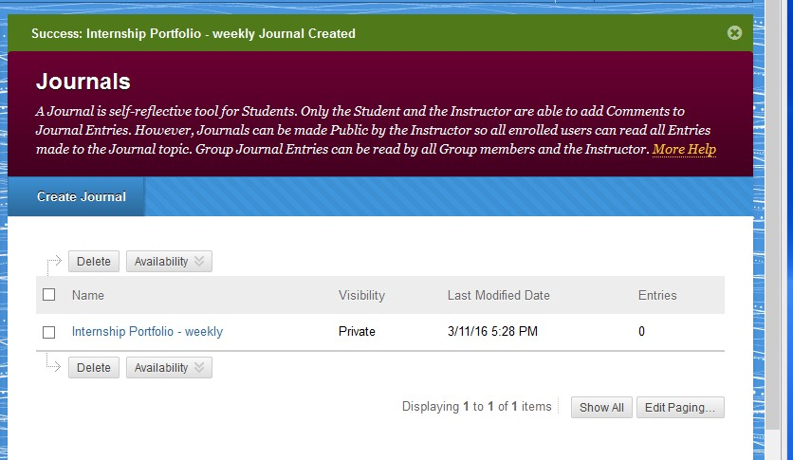

- Click on “Internship Portfolio-weekly”:

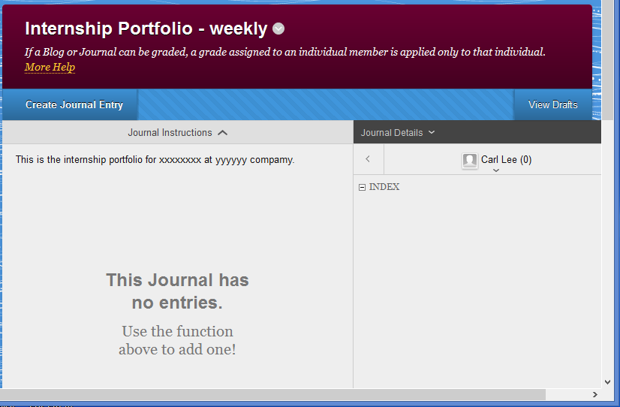

- Click on “Create Journal Entry” to start creating the first week e-Journal entry: Internship Information
In this first week entry, describe the internship time period, internship company/agency, internship field supervisor, internship duties, and anything else you want to document.

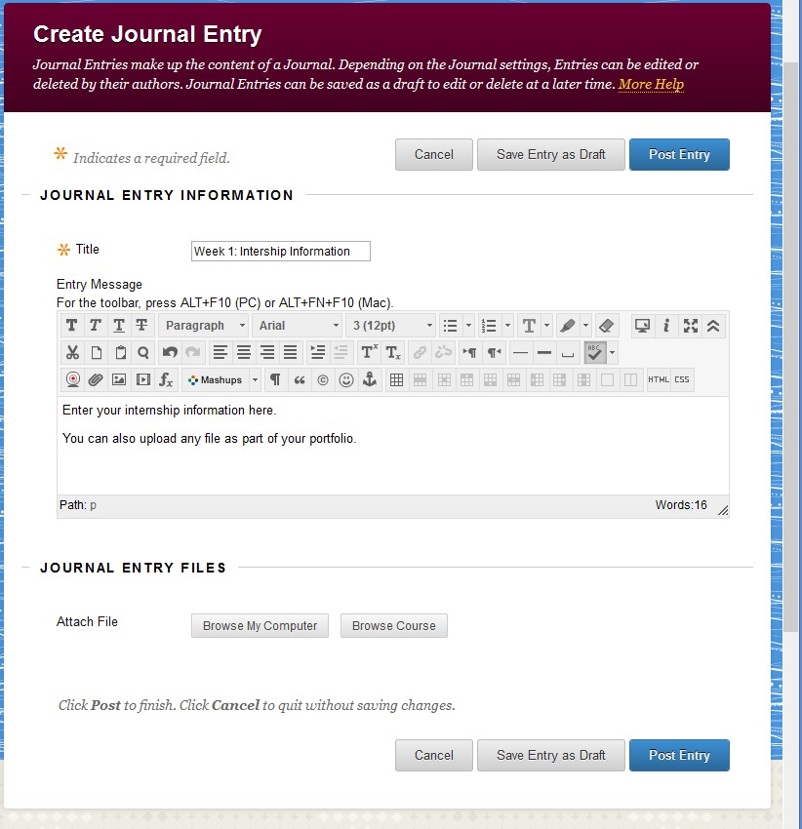

After clicking on “Post Entry”, your portfolio is kept on the Blackboard:

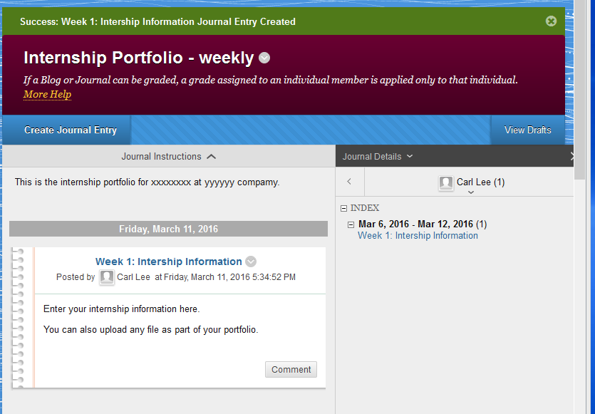

- At the end of each week, create a new weekly e-Journal entry with an appropriate entry name as you wish. Then, document the work, outcomes, lesson learned, etc.
You can attach any file that you would like to keep as the record for each weekly e-Journal entry.

An example of 1st and 2nd weeks portfolio’s weekly journal created:

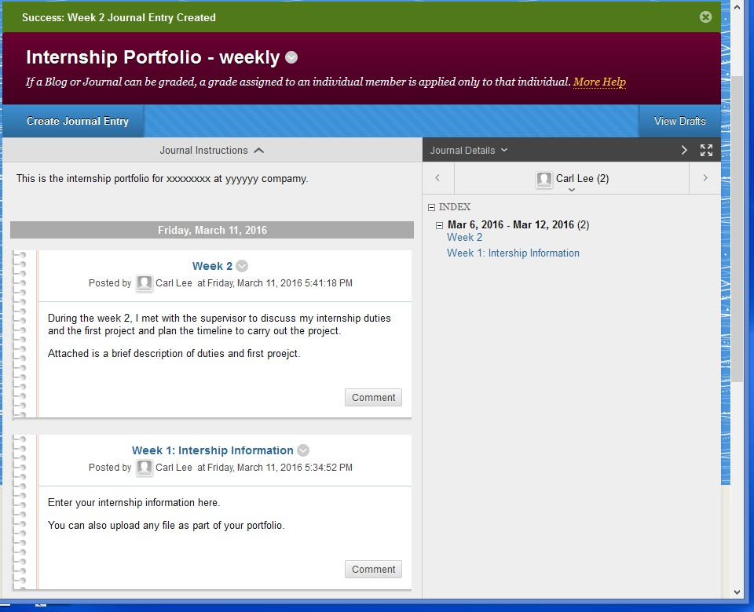

- At the end of the Internship, prepare your Final Internship Report, which will consist of your weekly e-Journal entries, a summary of major projects/activities and accomplishments, and lesson learned (see Final Internship Report Guidelines). Submit an e-copy of your Final Internship Report by e-mail to the Faculty Internship Coordinator during the final week of the internship.

Appendix B: Guidelines for documenting portfolio for teaching internship

It is intended that creation of the portfolio will provide the student with an opportunity to reflect upon the teaching experience. The portfolio may also aid the student in career advancement beyond the doctoral degree. The following items list some important requirements to be included in the portfolio.
  - A copy of the syllabus from the course being used for the internship.
  - A summary of different pedagogical methods used in the class; giving examples of each type.
  - A sample of lesson plans on topics explored with technology or other non-lecture pedagogy; a brief discussion of what happened when the lesson plan was implemented in the classroom; a discussion of the successes and failures of the lesson plan and why they occurred; and a discussion of what the graduate student would do differently if they taught this lesson again.
  - A brief discussion of expectations held about the students in the course and a comparison to how the students met or did not meet the instructor’s expectations during the semester.
  - A discussion of various assessment strategies used, and anonymous copies of student work from each type to be included.
  - The observation assessment documents made by the faculty member during the semester.

Appendix C: Teaching Internship Faculty Member Comment Form (An example)

Date:

    - Lesson Organization

    - Lesson Presentation

    - Observed Strengths

    - Suggestions for Improvement

    - Assessments and Grading

    - Other (attach any other written discussions from the faculty member)

Appendix D: Guidelines for documenting final internship report for non- teaching internship

The internship report must be submitted to the Internship Coordinator by the end of the final week of the internship, in order for the coordinator to meet the deadline for grade submission.

The following is the format outline for preparing your internship report.

- Cover page: Name, Contact Information, Time Period of the Internship, Internship Agency and address, and Internship Supervisor and contact information
- Table of Contents
- A summary section of major projects/activities during the Internship period.
- A section on ‘Lessons Learned from Internship Experience’ including
  - What positive changes have taken place in your attitude, self-confidence, skills and understanding of the working environment in an organization/company?
  - How relevant is the coursework to your internship? What was your best preparation? How should the coursework preparation be improved?
- Weekly e-Journal entries (downloaded from Blackboard)
- Others

Appendix E: Teaching Internship Assessment Form Evaluation of Intern and Internship Portfolio by the Internship Faculty Member

Teaching Internship Assessment Form
Evaluation of Intern and Internship Portfolio by the Internship Faculty Member

Student Name: _ Student ID: _ _

Semester:
Year: _

Course:
Course Reference Number:

Internship Faculty Member: Date Evaluated: _

Please evaluate the intern according to your observations and supervision of the work completed by the intern. Thank you for your time and cooperation.

Check only if applicable Satisfactory Unsatisfactory The intern:
Demonstrated appropriate mathematical/statistical knowledge

Demonstrated appropriate pedagogical content knowledge

Communicated effectively orally Communicated effectively in writing Demonstrated quality teaching Demonstrated appropriate use of technology Overall quality of work

_
_

Internship Portfolio: Satisfactory Unsatisfactory

Portfolio contains all required elements listed in Appendix B of the internship handbook:

The internship portfolio you received was:

Appendix F: Non-Teaching Internship Application Form (To be completed by the student)

Statistics, Actuarial and Data Sciences Department, Central Michigan University

Non-Teaching Internship Application Form (To be completed by the student)

PhD student: STA 795
MS Student: STA 695
Complete this form and attach an up-to-date resume to this form.
Send an e-copy to the Internship Director, Dr. Carl Lee by e-mail to carl.lee@cmich.edu

Today’s Date:
Internship Time Period: FROM: TO:
Student Name: | CMU Student Number:
Local Address:
Permanent Address:
Cell Phone: |  | E-mail Address:
Academic Advisor:

Internship Company/Agency:
Address of the Internship Agency:
Name of Agency Supervisor (if available):
E-mail address of the Agency Supervisor (if available):

Attach your up-to-date resume here:

Appendix G: Non-Teaching Internship Credit Agreement Form (To be Completed by the Field Supervisor)
Department of Statistics, Actuarial and Data Sciences, Central Michigan University

Non-Teaching Internship Credit Agreement Form (To be Completed by the Field Supervisor)
Student Name:
Organization/Company:
Supervisor Name: | Title:
Business Address:
Business Phone: | E-mail Address:
Internship Starting Date: | Internship Ending Date:
List major duties expected of the intern:
Indicate what form of compensation, if any, the intern will receive:
Additional conditions/ comments for the intern:

Field Supervisor Signature: | Date:

Appendix H: Evaluation Form of Intern by the Field Supervisor for Non- Teaching Internship

In order for the faculty internship Coordinator to complete the intern’s evaluation and to submit the grade in time, please send this evaluation form to the Faculty Internship

Coordinator, using the e-mail address: during the final week of the internship time period. Thank you very much.

Please evaluate the student intern according to your observations and supervision of her/his work as an intern. Your evaluation will be used to help determine the grade for the student’s internship experience and provide professional feedback to the student. Thank you for your time and cooperation.

Name of the Internship Company:

Name of the Field Supervisor: _
Date Evaluated:
Check only if applicable Satisfactory Unsatisfactory Possesses professional attitude
Willingness to assume responsibility Ability to meet deadlines
Ability to work on projects independently Ability to follow instructions
Ability to work with colleagues and supervisors Ability to analyze and synthesize
Ability to conduct research Ability to write
Ability to orally communicate Ability to use computers Overall quality of work

Did the student have adequate knowledge and skills required for this internship? Yes/No Comment:

What are the intern’s strength(s)?

What are the intern’s weakness(es)?

Appendix I: Evaluation Form of Intern by the Faculty Internship Coordinator for Non-Teaching Internship

Student Name: _ _ _ Student ID: _

Degree: Ph.D.
MS: _ Semester: _ Year:

Course: STA 795 _
STA 695_
Course Reference Number:

Name of the Internship Company: _

Internship Faculty Coordinator: _ _

Date Evaluated: _

Final Grade (CR or NC):

IMPORTANT: The internship report must be submitted to the Internship Coordinator no later than the end of the final week of the internship, in order for the coordinator to meet the deadline for grade submission.

Date the Internship Report is submitted:

INTERNSHIP AGREEMENT BETWEEN
Central Michigan University Board of Trustees
AND
________________________________________
This Agreement is entered into this _____ day of _______________, 20___ sets forth terms and conditions which govern the internship experience of students of Central Michigan University hereinafter referred to as “CMU” at _________________ located at ______________________________________ (address) hereinafter referred to as “Agency”.
Responsibilities of CMU:
- Plan and administer, in consultation with Agency, the internship experience in the _______________________ program for CMU student(s) assigned to Agency.
- Provide Agency with the name of student(s) to be assigned to the site as soon as possible after registration each semester.
- Inform student(s) that they shall be required to abide by the rules and policies of Agency. Upon notification from Agency of improper conduct by a student, CMU will immediately investigate and take appropriate action.
- Maintain all educational records of our students and comply with all statutes, rules and regulations regarding any release of information from such records. Agency shall have no responsibility regarding maintenance or release of such records.
- Ensure that student(s) have professional liability coverage under CMU’s General Liability Insurance Policy throughout the rotation.
- CMU shall recommend that student(s) have in force a health insurance policy to defray the cost of hospital or medical care that might be sustained during the period of placement. CMU shall inform student(s) of potential monetary liability the student(s) might incur as a result of failure to maintain sufficient coverage.
Responsibilities of Agency:
- Agency shall designate a primary supervisor of the student(s) who agrees to be available for instruction during the internship. Agency shall retain full responsibility for Agency’s operations and administration.
- Agency shall provide any pre-placement information that needs to be shared with the student(s), and provide any necessary orientation to the student(s) within the first week of placement.
- Agency shall have the authority to request the withdrawal of any student from the internship experience for reasonable cause related to the need to maintain an acceptable level of service and/or business operations. Such request shall be in writing. CMU will immediately comply with the request.
Mutual Terms:
- The student(s) assigned under this Agreement is/are assigned solely to obtain the educational experience contemplated under this Agreement. This Agreement is not an employment agreement between the student and Agency or student and CMU or Agency and CMU. Therefore, the student shall not be deemed an employee of Agency for purposes of compensation, fringe benefits, workers’ compensation, unemployment compensation, minimum wage laws, income tax withholding, social security, or for any other purpose because of his/her participation in the internship experience. During the period Student is a participant in the internship experience, Agency and the student may enter into an employment relationship. If Agency and student enter into an employment relationship, Agency and student shall establish any and all terms of that employment relationship, including hours, wages, and fringe benefits. CMU will not be a party to such an employment relationship. If Agency and student enter into such an employment relationship, that relationship shall be independent of, outside the scope of, and shall in no way modify or revoke the obligations of Agency and CMU under this agreement, unless the parties expressly provide otherwise in writing.
- Both parties shall maintain Comprehensive General Liability Insurance or its equivalent.
- In the performance of their respective duties and obligations under this Agreement, CMU and Agency are independent contractors, and neither is the agent, employee or servant of the other, and each is responsible for its sole conduct. There shall be no monetary consideration paid by either party to the other.
- Each party agrees to comply with and to be separately responsible for compliance with all laws, including but not limited to anti-discrimination laws, which may be applicable to their respective activities under this program. Both parties shall not discriminate on the basis of sex, disability, race, national origin, color, creed, religion, marital status, height, weight, veteran status, sexual orientation or gender identity, or age.
- This agreement shall be effective on the ____ day of __________ (month) of ______ (year) and shall terminate on the _____ day of __________ (month, ______ (year). However, it may be terminated by either party upon forty-five (45) days written notice of termination to the other party, provided, however, that the student then receiving instruction in any program shall be given an opportunity to complete the full program during his/her instructional period.
IN WITNESS WHEREOF, the parties hereto have executed this Agreement as of the day and year first above written.
AGENCY: | UNIVERSITY:
By: | By:
Name: | Name: Dr. Ian R. Davison
Title: | Title: Interim Senior Vice Provost for Academic Affairs  and Professor of Biology
Date: | Date:

Appendix K: Checklist for Completing a Non-Teaching Internship

Ph.D. in Statistics and Analytics, Internship course STA 795
M.S. in Applied Statistics and Analytics, Internship course STA 695

When | Task to Complete
Prior to Internship | - Carefully read the Non-Teaching Internship Handbook
Prior to Internship | - Complete the prerequisite:  PhD: Pass three qualifying Exam. MS: Complete one year of course work
The semester BEFORE your internship | - Prepare your resume.  Contact the Faculty Internship Coordinator to discuss your internship interests, identify possible internship sites.
The semester BEFORE your internship | - Contact the internship site to learn more about the internship opportunity. Follow the process to apply for the internship, contact the site and schedule an interview at the site, and to secure an internship opportunity.
After securing the Internship, PRIOR to the BEGINNING of internship | - Register for the adequate course: STA 795 or STA 695  Contact your internship site to identify your field supervisor and become familiar with the internship agency.  Complete the Department Internship Form (Appendix F). Complete the Internship Credit Agreement (Appendix G).  Complete the Agreement between CMU and the Internship Agency (Appendix J )  If you are an international student using F-1 visa, complete the CPT Recommendation Form and follow the procedure in 2.11 to apply for CPT.
 | - Complete the evaluation of the Authorization of Degree Program: Contact your Academic Advisor to complete this evaluation though the “Degree {Progress Admin site at https://apps.cmich.edu/tools/workbench/ .
At the BEGINNING of  the internship | Attend Agency Orientation to become familiar with the agency, the company culture and missions, and your working environment
Every week during the internship | Complete the weekly e-Journal entries on the Blackboard site describing your experience such as project and accomplishment, etc.
During the first two weeks of the internship | Get acquainted with employees, co-workers.  Working with your internship supervisor to plan the internship project(s) and create a timeline for accomplishing your internship project.  Create the e-Journal entry on the Blackboard site as part of your portfolio.

During the Internship | Check with the Graduate Office for graduation deadline and apply for graduation, if applicable. Apply online at www.grad.cmich.edu
HALFWAY through the internship | Schedule a site visit with the Faculty Internship Coordinator, if it possible (e.g., the site is not far from CMU).
At END of the internship | - Discuss Final Internship Evaluation with Agency Supervisor.  Inform the Agency Supervisor to e-mail his/her evaluation form to Faculty Internship Coordinator.
At END of the internship | - Prepare your final internship report. Follow the internship report format to prepare your internship report and submit it by e-mail to the Faculty Internship Coordinator.
At END of the internship | - After submitting your internship report, schedule a meeting with the Faculty Internship Coordinator to discuss your internship experience. Faculty Internship Coordinator will assign you a grade.

