Human Demography

Introduction
As the United States has progressed through the industrial revolution over the last 150 years, changes in the life-styles of citizens have been reflected in their age at death. Factors such as diseases and accidents have changed in their relative impacts. One way to study these changes in human demographic patterns is to visit a local cemetery and collect dada recorded on tombstones.
By collecting information on the year of death for all individuals of the same age class (a cohort) you can produce a graphical representation of their survivorship. For this exercise a cohort will include all of the individuals born during the same decade.
For the numerous species studied, the curves usually fit one of three general shapes (Figure 1). Human survivorship typically fits a Type 1 curve. Especially interesting though is that slight, but distinct, differences can be seen when curves from separate communities are compared, or when cohorts from different decades for a single community are compared, as you will do during this lab.
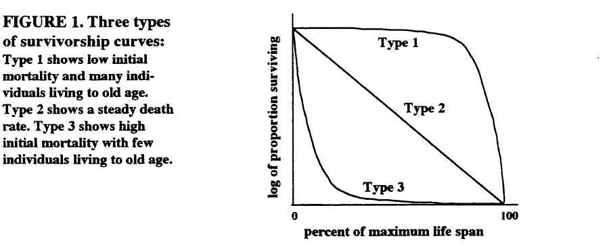

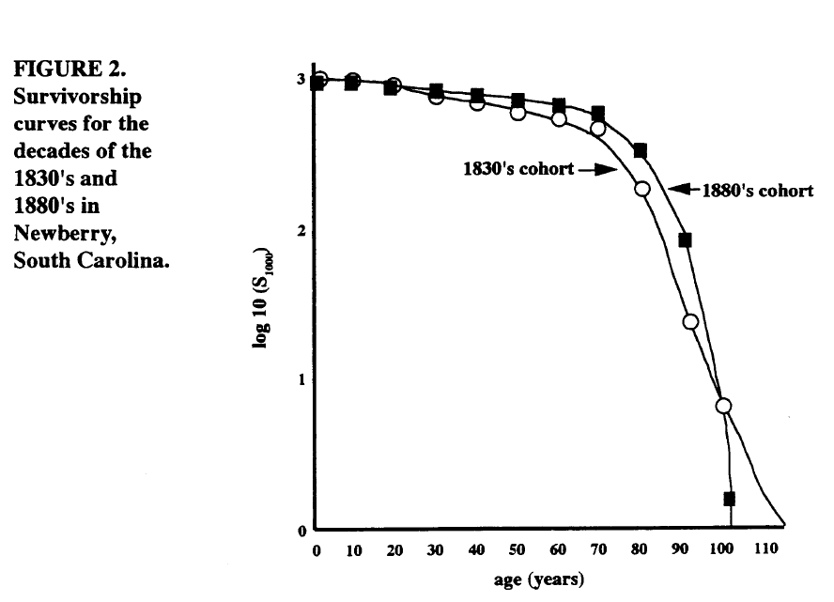

Objectives
In today's lab you will
- Compare and explain the differences in the survivorship curves for at least two cohorts in a community with respect to local or national history.
- Speculate on future changes in demography, based on current community changes.
- Collect age data and calculate survivorship for at least two cohorts in a community. Graph these dada to show a survivorship curve for each decade you studies.

KEY WORDS
Be able to define the following terms.
Survivorship Curves | Type 1 | Type 2
Type 3 | Cohort Life Table | Static Life Table
Fecundity

background

directions
Field:
- Divide class into groups of 3
- Each group responsible for one region of cemetery (90-150 graves).
- Each person in the group is responsible for collecting data on one specified cohort only. Example cohorts: Died before 1910, died 1911-1950, died after 1951
- Each person should collect 20 graves
- Keep males and females separate for easy collation.
Laboratory
- For each individual calculate the age at death (Table 1 and 2).
- Summarize the data in Table 3. Note data are clustered into age classes (first column) of ten-year intervals. For the 0-9 age class, count all of the individuals which died at an age of 9 or less. Continue to record the number of deaths for each of the age classes. The number of deaths for an age class is commonly abbreviated as “d_{x}”. When you reach the bottom of the column, determine the total number of deaths and record this number in the indicated space on Table 4. This number should equal the total number of tombstones you counted for that decade.
- The third column of survivorship data (n_{x}) and the calculations of these data are cumulative. Begin by placing a zero (0) in the lowest box of the column. To determine the number of for the next box up add to the zero the number for the number of deaths (d_{x}) that appears in the column to the left and one row up. Continue this process of adding on the number to the left and one row up to determine the data for each row of the survivorship column. When you reach the top you should have the total number of tombstones that you originally counted. (See Table 5 for an example of properly formatted data.)
- Standardize the survivorship data to per 1000 (S₁₀₀₀) to allow you to compare data from the two decades. Use these equations to make the necessary calculations.
S₁₀₀₀ = (l_{x}) ∗ (1000) Remember, l_{x} = n_{x}/n₀
To check your calculations for correctness, the top line should be 1000 and the bottom line zero.
- To standardize your data for graphing, calculate the logarithm to the base ten (10) of each number in the “survivorship per 100” column. Once again to check your calculations, the number in the top row should be 3 and the bottom line will produce an error (log 0 is undefined) on your calculator. For this number just put “0”.
- Using graph paper, plot your data with the x-axis representing time and the y-axis representing the log of the proportion of individuals surviving. Compare your data with Figures 1 and 2.

DISCUSSION QUESTIONS
- Do the curves for the different decades differ from one to another? If so, what might have caused the differences?
- How do your graphs compare with Figure 1, survivorship curves for different types of populations and with Figure 2, survivorship curves for Newberry, South Carolina. Can you explain any differences?
- How would your data have been altered if your cemetery had closed in 1965 rather than being opened to the present day?
- One problem with studying survivorship curves is that a birth cohort must be followed until all individuals have died. What differences would you expect to see between the survivorship curves from an 1870’s cohort and a 1940’s cohort?
- What would future survivorship curves look like if
- AIDS continues to increase and no cure is found?
- Medical advances continue and most diseases and infant mortality are eliminated?
- Environmental problems deteriorate and pollution-related disease increases?
- What assumptions did you need to make in order to develop the survivorship curves for Mt. Pleasant?

REFERENCES
Condran, G. and E. Crimmins. 1980. Mortality differentials between rural and urban areas of states of the northeastern United States 1890-1900. Journal of Historical Geography 6 (2): 179-202.
Dethlefsen, E.S. and K. Jensen. 1977. Social commentary for the cemetery. Natural History 86(6) 32-29.
Gwatkin, D.R. and S.K. Brandel. 1982. Life expectancy and population growth in the third world. Scientific American 246(5): 57-65.
Kuntz, S. 1984. Mortality change in America, 1620-1920. Human Biology 56: 559-582.
Mahler, H. 1980. People. Scientific American 243 (3):67-77.

Table 1. Data collection sheet - MALES
Time Period _________________________

# of indiv. | Birth Yr. | Death Yr. | Age at Death | Sex |  | # of indiv. | Birth Yr. | Death Yr. | Age at Death | Sex
1 |  |  |  |  |  | 26
2 |  |  |  |  |  | 27
3 |  |  |  |  |  | 28
4 |  |  |  |  |  | 29
5 |  |  |  |  |  | 30
6 |  |  |  |  |  | 31
7 |  |  |  |  |  | 32
8 |  |  |  |  |  | 33
9 |  |  |  |  |  | 34
10 |  |  |  |  |  | 35
11 |  |  |  |  |  | 36
12 |  |  |  |  |  | 37
13 |  |  |  |  |  | 38
14 |  |  |  |  |  | 39
15 |  |  |  |  |  | 40
16 |  |  |  |  |  | 41
17 |  |  |  |  |  | 42
18 |  |  |  |  |  | 43
19 |  |  |  |  |  | 44
20 |  |  |  |  |  | 45
21 |  |  |  |  |  | 46
22 |  |  |  |  |  | 47
23 |  |  |  |  |  | 48
24 |  |  |  |  |  | 49
25 |  |  |  |  |  | 50

Table 2. Data collection sheet - FEMALES
Time Period _________________________

# of indiv. | Birth Yr. | Death Yr. | Age at Death | Sex |  | # of indiv. | Birth Yr. | Death Yr. | Age at Death | Sex
51 |  |  |  |  |  | 76
52 |  |  |  |  |  | 77
53 |  |  |  |  |  | 78
54 |  |  |  |  |  | 79
55 |  |  |  |  |  | 80
56 |  |  |  |  |  | 81
57 |  |  |  |  |  | 82
58 |  |  |  |  |  | 83
59 |  |  |  |  |  | 84
60 |  |  |  |  |  | 85
61 |  |  |  |  |  | 86
62 |  |  |  |  |  | 87
63 |  |  |  |  |  | 88
64 |  |  |  |  |  | 89
65 |  |  |  |  |  | 90
66 |  |  |  |  |  | 91
67 |  |  |  |  |  | 92
68 |  |  |  |  |  | 93
69 |  |  |  |  |  | 94
70 |  |  |  |  |  | 95
71 |  |  |  |  |  | 96
72 |  |  |  |  |  | 97
73 |  |  |  |  |  | 98
74 |  |  |  |  |  | 99
75 |  |  |  |  |  | 100

TABLE 3. Data compilation for all of the groups of one time period.
Male
AGE | GRP 1 | GRP 2 | GRP 3 | GRP 4 | GRP 5 | GRP 6 | GRP 7 | GRP 8 | Total
0-9
10_19
20-29
30-39
40-49
50-59
60-69
70-79
80-89
90-99
100-109
110-119
Female
AGE | GRP 1 | GRP 2 | GRP 3 | GRP 4 | GRP 5 | GRP 6 | GRP 7 | GRP 8 | Total
0-9
10_19
20-29
30-39
40-49
50-59
60-69
70-79
80-89
90-99
100-109
110-119

TABLE 4: Data calculations for survivorship curve.

STUDENT NAMES
CEMETERY

COHORT

TIME PERIOD

Age Class  (Years) | # Deaths  (d_{x}) | # Survivors  (n_{x}) | Proportion Surviving (l_{x}) | Survivorship per 1000 (S₁₀₀₀) | Log (S₁₀₀₀)
0-9
10-19
20-29
30-39
40-49
50-59
60-69
70-79
80-89
90-99
100-109
+110

TABLE 5: Survivorship table summarizing data collected for the 1830’s from a cemetery in Newberry, South Carolina.

Age Class  (Years) | # Deaths  (d_{x}) | # Survivors  (n_{x}) | Proportion Surviving (l_{x}) | Survivorship per 1000 (S₁₀₀₀) | Log (S₁₀₀₀)
0-9 | 8 | 160 | 1.000 | 1000 | 3.00
10-19 | 7 | 152 | 0.950 | 950 | 2.98
20-29 | 13 | 145 | 0.906 | 906 | 2.96
30-39 | 9 | 132 | 0.825 | 825 | 2.92
40-49 | 13 | 123 | 0.769 | 769 | 2.89
50-59 | 21 | 110 | 0.688 | 688 | 2.84
60-69 | 23 | 89 | 0.556 | 556 | 2.75
70-79 | 39 | 66 | 0.413 | 413 | 2.62
80-89 | 22 | 27 | 0.169 | 169 | 2.23
90-99 | 4 | 5 | 0.031 | 31 | 1.49
100-109 | 1 | 1 | 0.006 | 6 | 0.78
+110 | 0 | 0 | 0.000 | 0 | *0

* Log (0) is undefined. Consider this value zero.

